**Create And Configure IBM Cloud Service Create Node-RED Service**

|  |  |
| --- | --- |
| **Date** | **04 November 2022** |
| **Team ID** | **PNT2022TMID16953** |
| **Project Name** | **loT Based Safety Gadget For Child Safety Monitoring & Notification** |
| **Maximum Marks** | **4 Marks** |

**AIM**

To Create Node-RED service.

**STEPS**

1. Login to IBM Cloud with smart internz mail ID and Password.

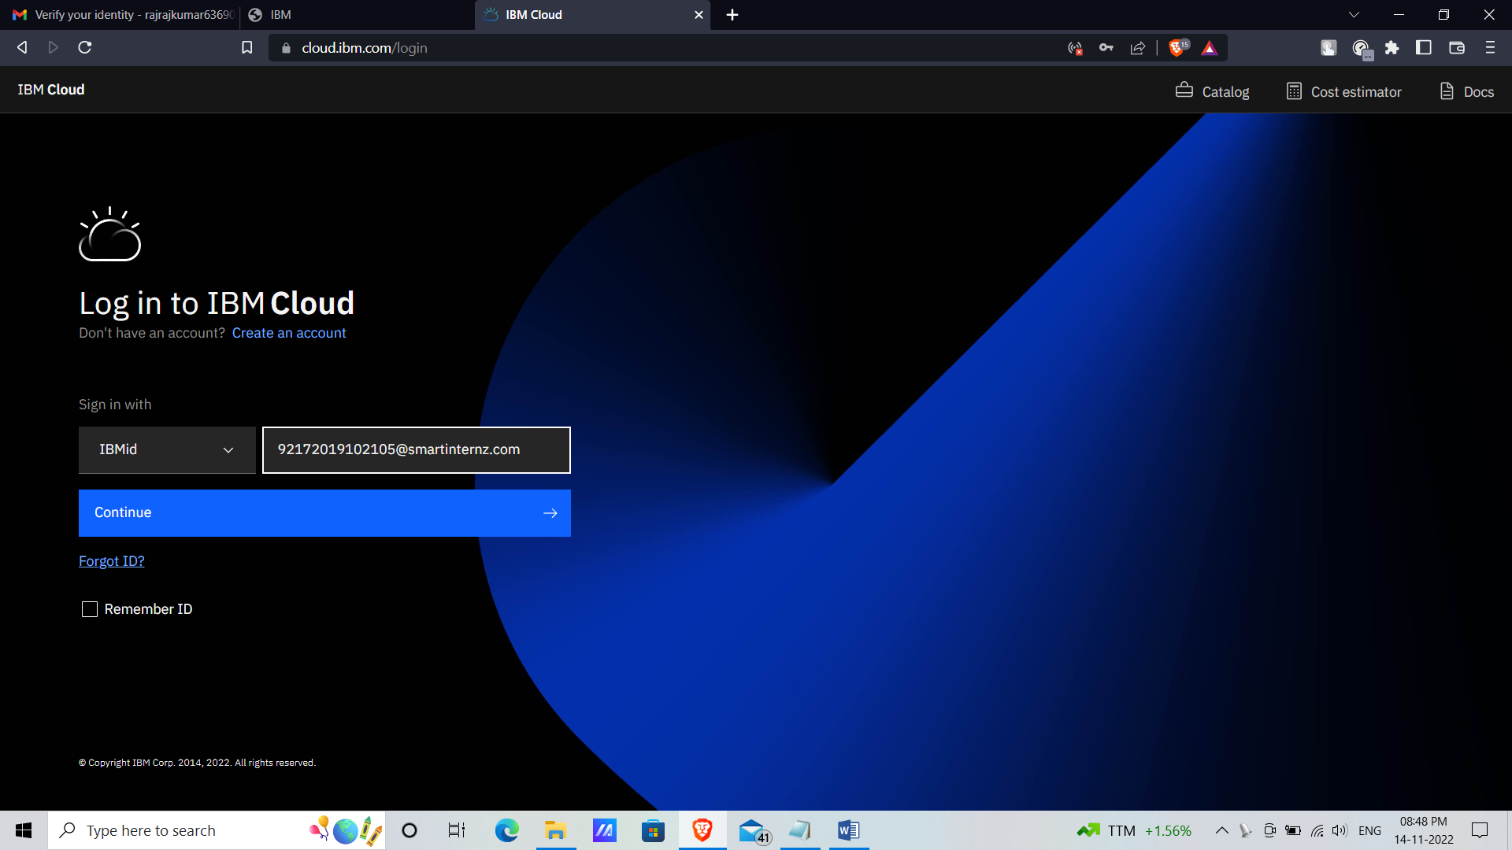

1. Go to Catalog and Search for Node-red App in the search bar.

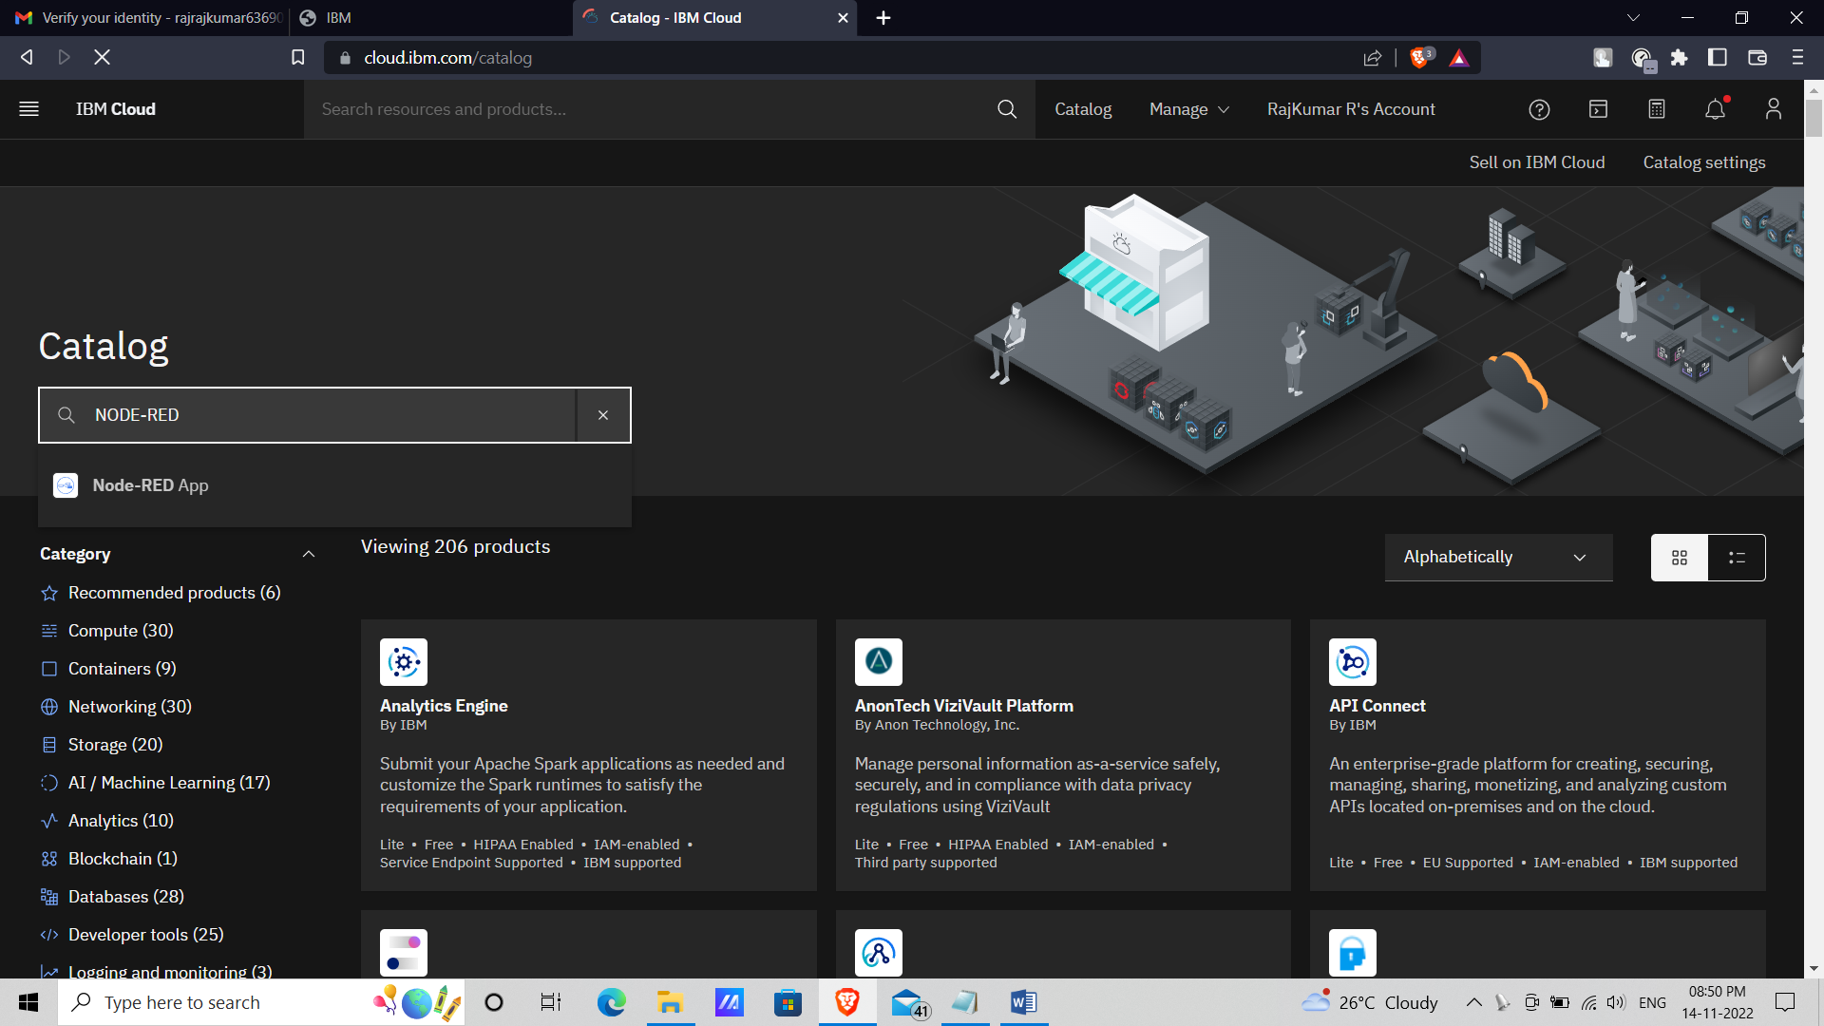

1. Open Node-red App and click get start.

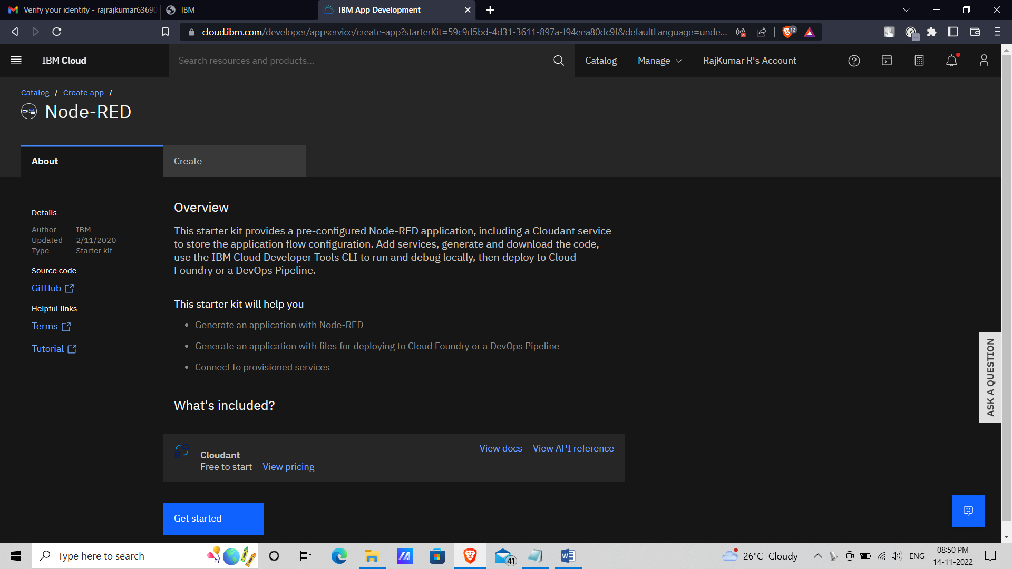

1. In next page click create.

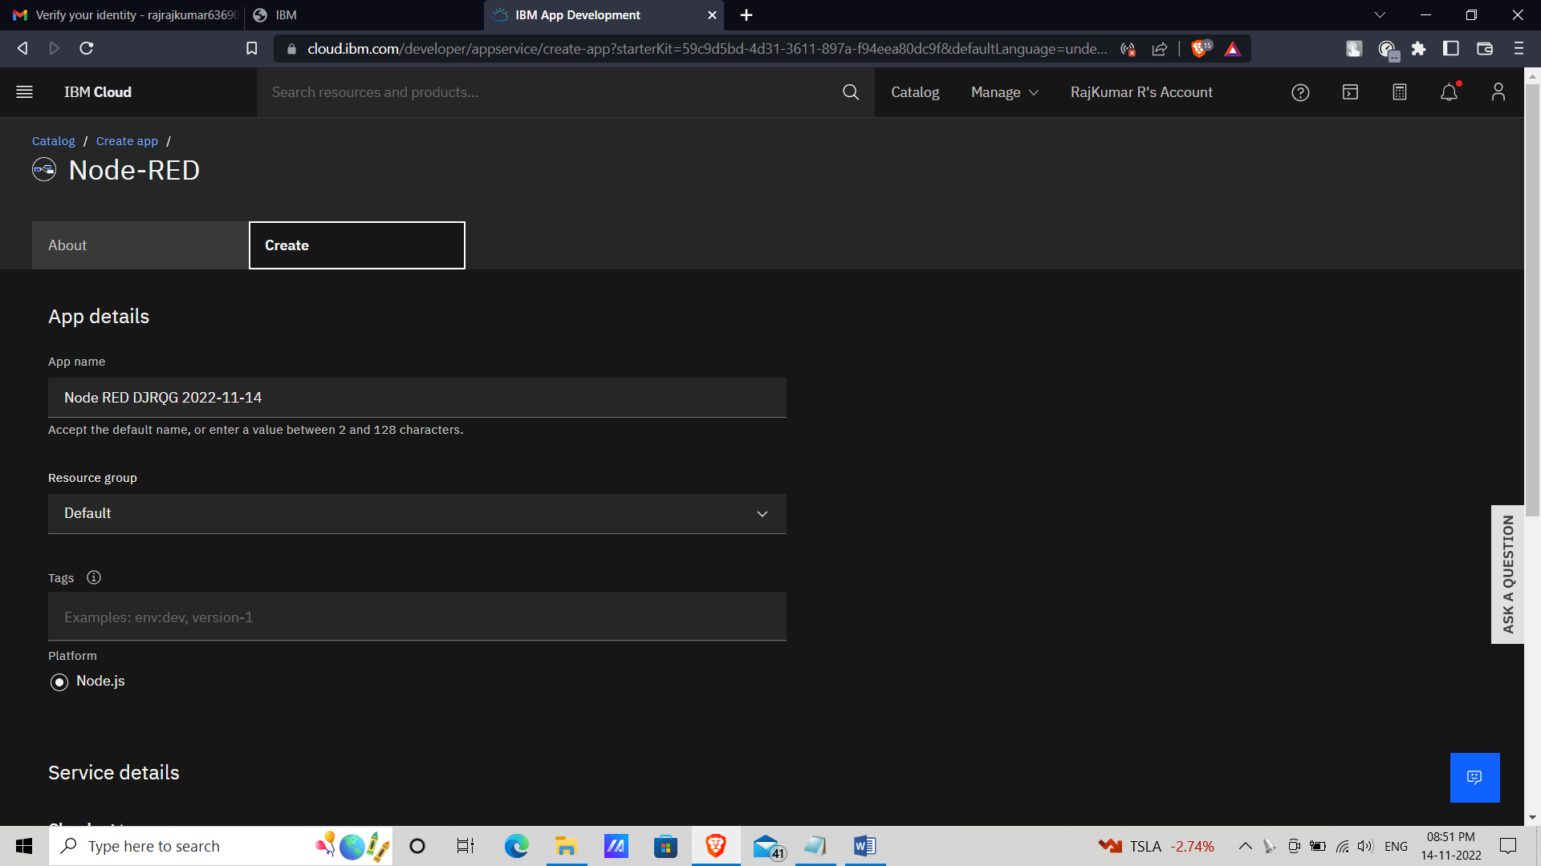

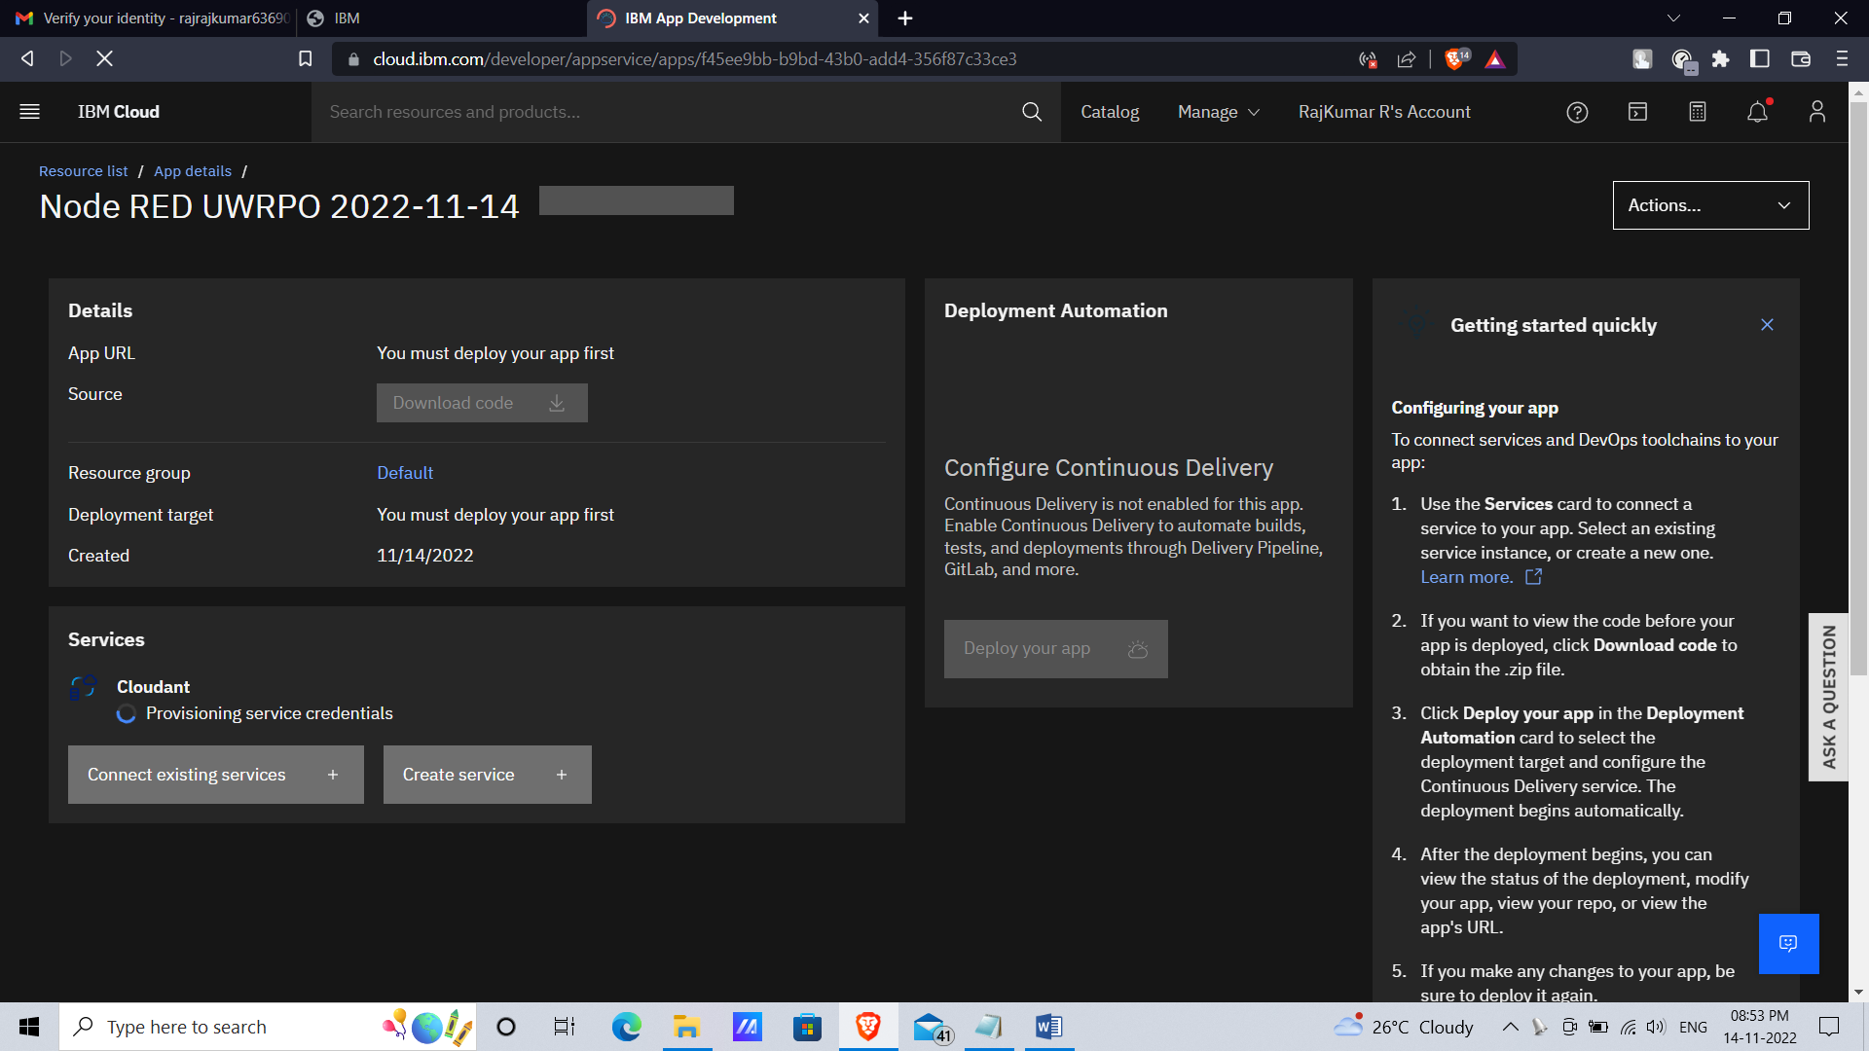

1. Click Deploy your app and it come to this page and select cloud foundry.

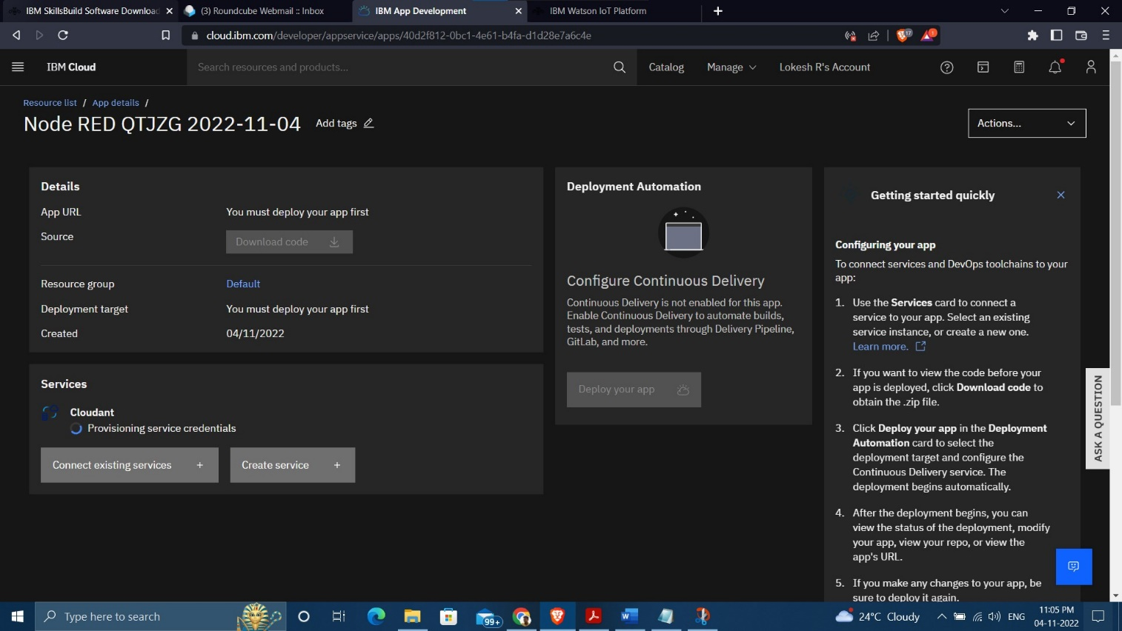

1. Setting up the environment and deploying the app.

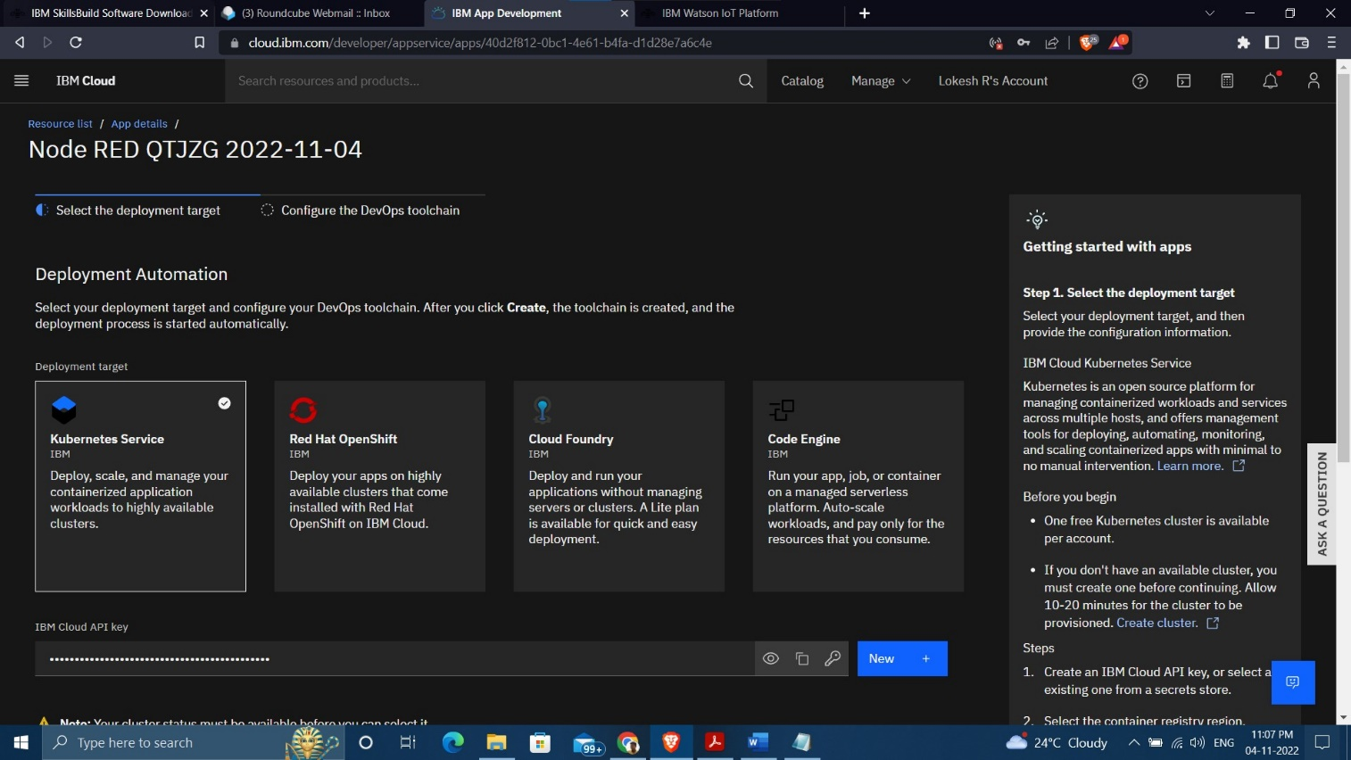

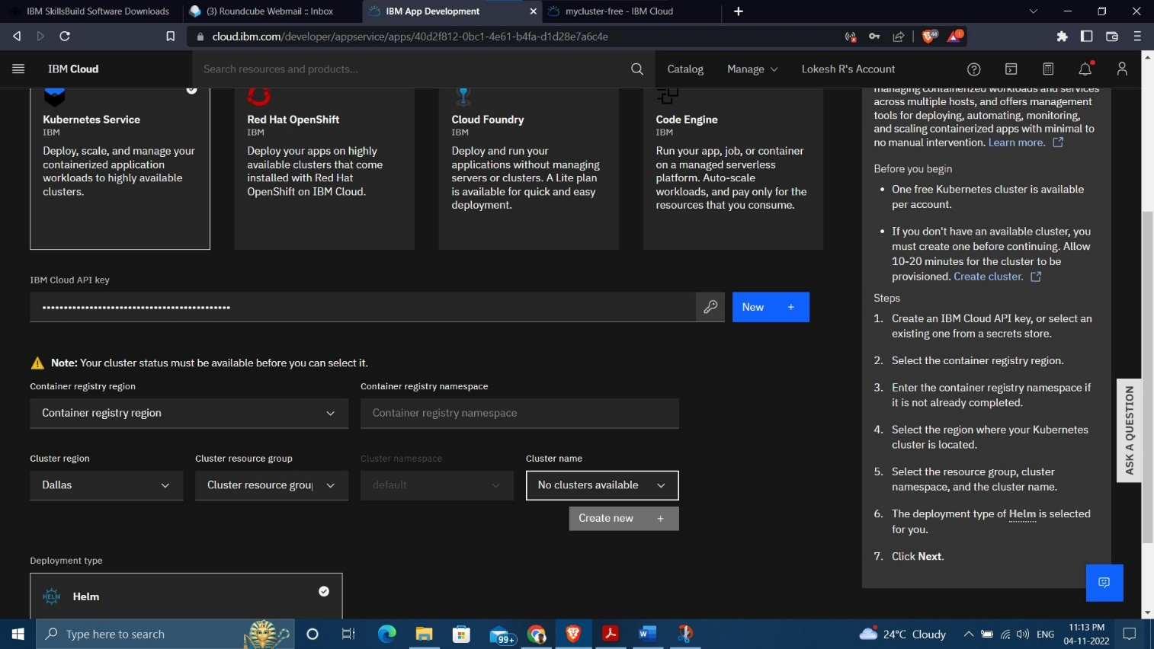

1. Successfully creating the app.

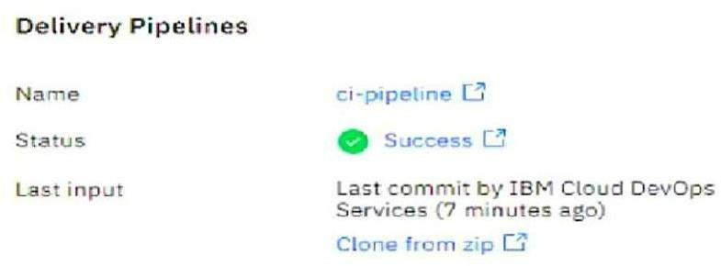

And it's work Successfully

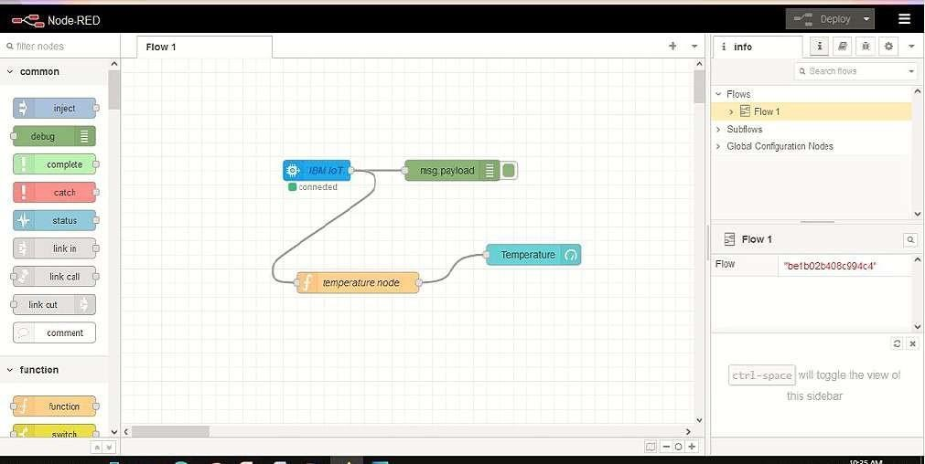

**RESULT**:

Successfully created the Node-RED service.

**TEAM ID : PNT2022TMID16953**

**TEAM LEADER : RAJKUMAR R**

**TEAM MEMBER 1 : RISHIRAM K**

**TEAM MEMBER 2 : KARAN B**

**TEAM MEMBER 3 : SANTHOSH M**

**TEAM SIZE 4**

**MENTOR : SIVA T**